Experiment: Implementation of Expectation-Maximization (EM) Algorithm in Python
Aim
To implement the Expectation-Maximization (EM) Algorithm in Python for clustering data using a Gaussian Mixture Model (GMM).
Theory
The Expectation-Maximization (EM) algorithm is an unsupervised machine learning algorithm used to estimate the parameters of probabilistic models. It is commonly used for clustering using Gaussian Mixture Models (GMM).
The EM algorithm consists of two steps:
- Expectation (E-Step): Calculates the probability that each data point belongs to each cluster.
- Maximization (M-Step): Updates the cluster parameters (mean, covariance, and weights) based on these probabilities.
These two steps are repeated until the algorithm converges.
Procedure
- Import the required Python libraries.
- Load the Iris dataset.
- Select two features for visualization.
- Create the Gaussian Mixture Model (GMM).
- Train the model using the EM algorithm.
- Predict the cluster labels.
- Display the cluster assignments.
- Plot the clustered data points.
Python Program
from sklearn.datasets import load_iris
from sklearn.mixture import GaussianMixture
import matplotlib.pyplot as plt
# Load Iris dataset
iris = load_iris()

# Select two features for visualization
X = iris.data[:, :2]
# Create Gaussian Mixture Model
gmm = GaussianMixture(n_components=3, random_state=42)
# Train the model
gmm.fit(X)
# Predict cluster labels
labels = gmm.predict(X)
# Display first 10 cluster labels
print("Cluster Labels:")
print(labels[:10])
# Plot the clusters
plt.scatter(X[:, 0], X[:, 1], c=labels, cmap='viridis')
plt.xlabel("Sepal Length")
plt.ylabel("Sepal Width")
plt.title("Expectation-Maximization (Gaussian Mixture Model)")
plt.show()
Output
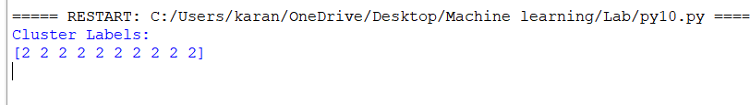
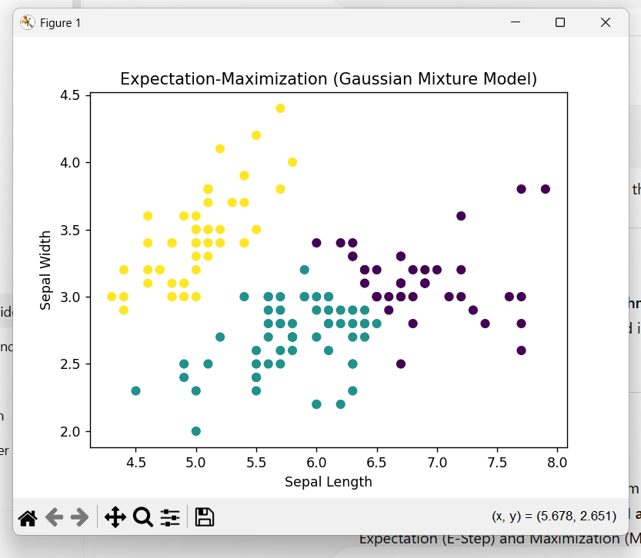
Result
The Expectation-Maximization (EM) algorithm was successfully implemented using the Gaussian Mixture Model (GMM). The Iris dataset was clustered into three groups, and the resulting clusters were visualized using a scatter plot.

